We recognise that the children can only perform at a high level if they are given opportunities to do so and this growth mindset is an integral part of teaching and learning at Crackley Hall. It is a mindset which encourages students to become independent, robust and enquiring and embeds a culture of challenge, aspiration and dedication throughout the school.

Tasks which offer our pupils the opportunity to demonstrate their ability, task commitment and creativity are firmly embedded in the day-to-day delivery of the curriculum, exposing learners to a range of learning resources, challenging questions and high-level thinking skills. We believe that the presence of the Junior da Vinci Programme alongside the established provision for all our pupils, as well as for those children who are particularly more able, gifted or talented, will enhance the learning experience for all in school.

If you have any queries or require any further information, please contact:

Mrs Margaret Spillane
Co-ordinator for the Junior da Vinci programme

“ Do not bury your talents, the gifts that God has given you. Do not be afraid to dream of great things!”

Pope Francis

Crackley Hall School

Junior da Vinci Programme

September 2019

Parent Guide

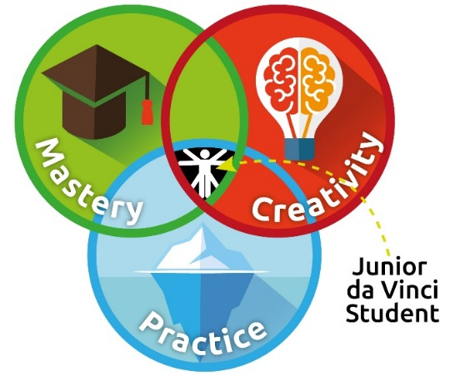

At Princethorpe College, the Da Vinci programme was introduced as an integral part of their provision for gifted and talented pupils. At its essence, though, is the proposition of the Renaissance ideal that all people should endeavour to develop their capacities as fully as possible, to enjoy broad interests, profound knowledge and wide ranging accomplishments. Whilst we may be born with certain predispositions, we are completely able to change and develop skills as much as we wish; when a student demonstrates three interlocking traits - ability, task commitment and creativity - they will achieve a high level of performance.

In September 2017, Crackley Hall launched their own Junior da Vinci Programme within the Junior School (Years 3-6). This year the programme has been extended to KS1 (J1-2).

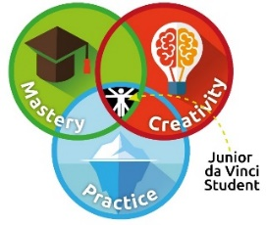
The children are encouraged to embrace three adapted principles – Creativity, Practice and Mastery – into their approach to learning. In this way, the children can be inspired to be the best that they can be from whatever starting point that they may have and, in particular, those pupils who are already achieving at a high level can be spurred on to see that the path of learning and
discovery does not stop when they have achieved a certain level.

“The master is the one who is willing to try and fail, and try again, for as long as he or she lives.” George Leonard

When the children produce exceptional work or learning across the curriculum, demonstrating at least one aspect of the three principles, they will be awarded a sticker or stamp in their school diary for that particular principle. The award will be recorded on our school data system by their teachers so that we can track the pupils achieving Junior da Vinci merits in Creativity, Practice and Mastery. One merit will also be worth three housepoints; we want the children to view their achievement also as a contribution to their school house and consequently to the success of their peers.

The children’s merits will be recognised at regular assemblies. When a pupil has earned all three aspects – Creativity, Practice and Mastery – they will be awarded a special Junior da Vinci award to recognise their achievement of all three Junior da Vinci traits.

They will receive a badge and certificate at the end of the half-term; parents will be informed when these will be awarded at assembly. At the end of the year, Princethorpe will award trophies to the girl and boy in the school who have achieved the most complete Junior da Vinci awards (Mastery, Creativity & Practice in one subject) and this will be presented at our annual School Prize Giving.

